# Angular 2 new features

Has ES6 specifications and built using typescript

Some of the other interesting features in Angular 2 are:

* Form Builder
* Change Detection
* Templating
* Routing
* Annotations
* Observables
* Shadow DOM

# Components, Modules, Classes, TypeScript

# ES6

JavaScript was created in 1995, but the language is still thriving today. There are subsets,

supersets, current versions and the latest version ES6 that brings a lot of new features.

Some of the highlights:

* Classes
* Arrow Functions
* Template Strings
* Inheritance
* Constants and Block Scoped Variables
* Spread and Rest operators
* Destructuring
* Modules

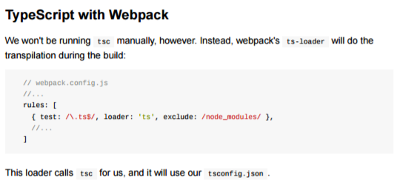

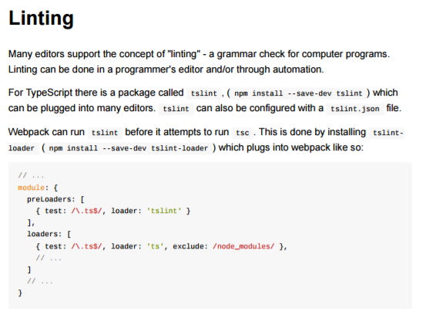

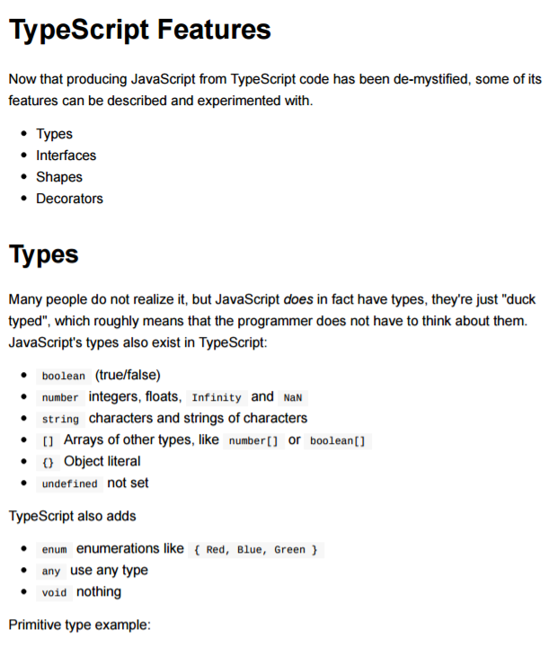

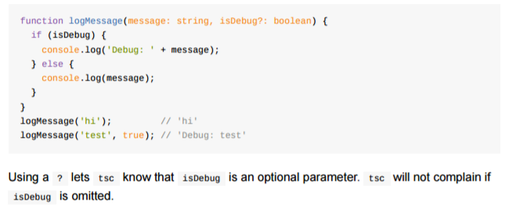

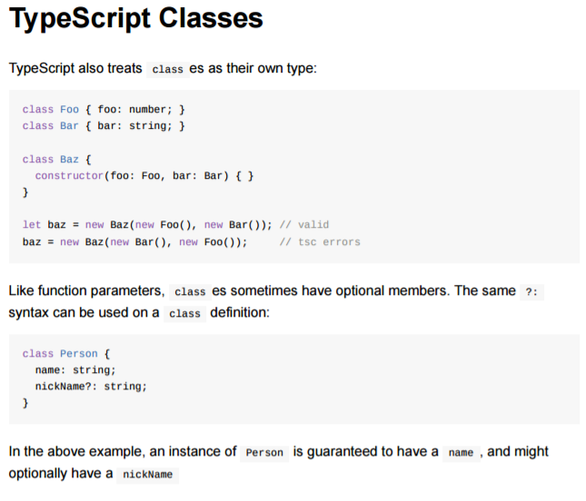

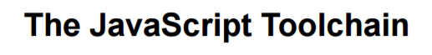

NodeJs, WebPack, …



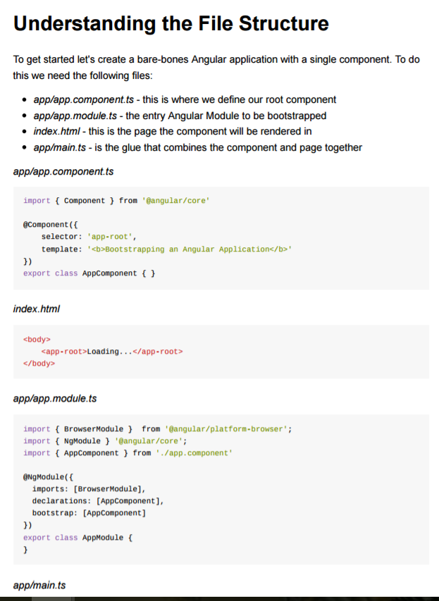

Service classes == providers

